
1

Replace the number in AX by its absolute value:

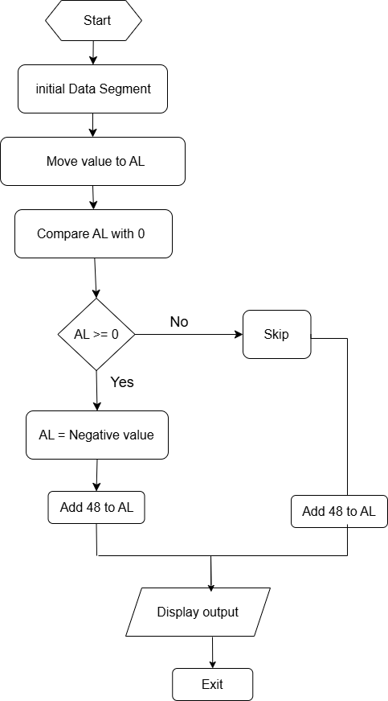

Suppose AL and BL contain extended ASCII characters. Display the one that comes first in the character sequence:

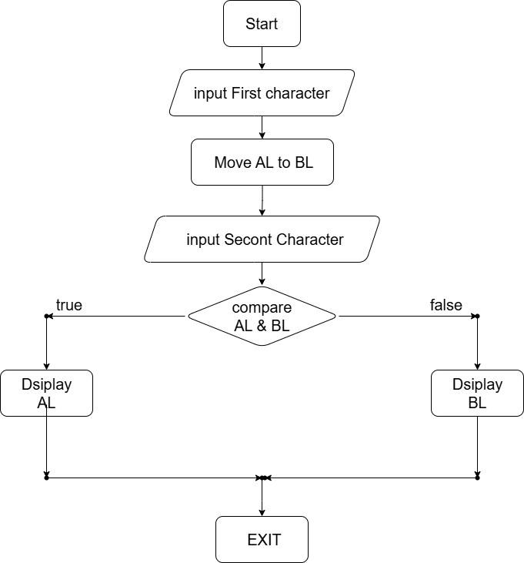

If AX contains a negative number, put -1 In BX; if AX contains 0, put 0 In BX; if AX contains a positive number, put 1 In BX:

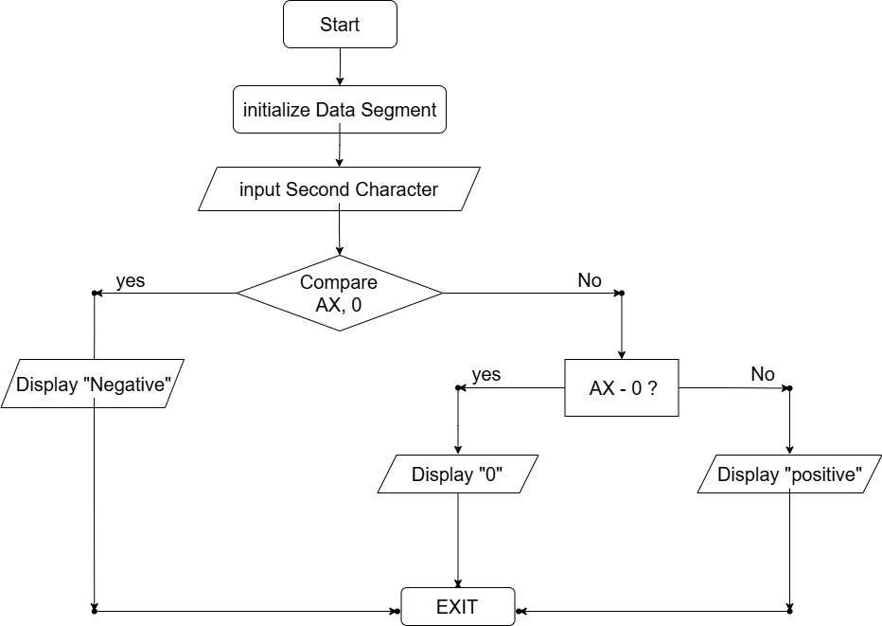
Code:

Replace the number in AX by its absolute value:
.model small
.stack 100h

.data

.code
main proc
; Initialize the data segment
mov ax, @data
mov ds, ax

; Move -5 into AL (input value)
mov al, -5

; Check if AL is less than 0
cmp al, 0
jge nothing ; Jump to 'nothing' if AL is greater or equal to 0
neg al ; Otherwise, negate AL

nothing:
; Convert number to ASCII
add al, 48

; Prepare for character output
mov ah, 2
mov dl, al

; Output the character
int 21h

; Terminate the program
mov ah, 4ch
int 21h

exit:
mov ah, 4ch
int 21h
main endp

end main

Output:
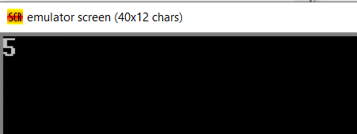

Suppose AL and BL contain extended ASCII characters. Display the one that comes first in the character sequence:

.model small
.stack 100h

.data

.code
main proc
; First input character
mov ah, 1 ; Single character input
int 21h
mov bl, al

; Second input character
mov ah, 1 ; Single character input
int 21h

; Check if al < bl
cmp al, bl
jl display_al

; Else,
mov ah, 2 ; Single character output
mov dl, bl
int 21h ; Display bl
jmp exit

display_al:
mov ah, 2 ; Single character output
mov dl, al
int 21h ; Display al

exit:
mov ah, 4ch ; Exit program
int 21h

main endp
end main

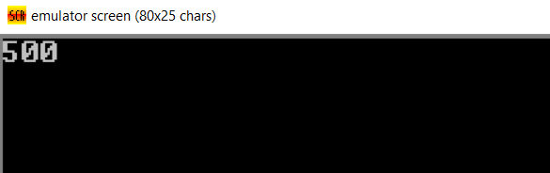
Output:

If AL contains 1 or 3, display "o"; if AL contains 2 or 4, display "e":

.model small
.stack 100h

.data

.code
main proc
mov ax, @data
mov ds, ax

mov ah, 1 ; Single character input
int 21h

; Check odd
cmp al, '1'
je odd
cmp al, '3'
je odd

; Check even
cmp al, '2'
je even
cmp al, '4'
je even

odd:
mov dl, 'o'
jmp display ; Skip the even label

even:
mov dl, 'e'

display:
mov ah, 2 ; Single character output
int 21h ; Show output

mov ah, 4ch ; Exit program
int 21h

main endp
end main

Output-Even:
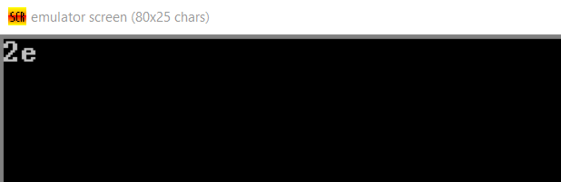

Output-Odd:
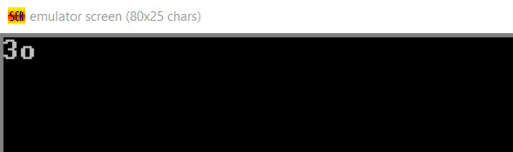

If AX contains a negative number, put -1 In BX; if AX contains 0, put 0 In BX; if AX contains a positive number, put 1 In BX:

.model small
.stack 100h

.data
Message_neg db 'Negative', 0dh, 0ah, '$'
Message_zero db 'Zero', 0dh, 0ah, '$'
Message_pos db 'Positive', 0dh, 0ah, '$'

.code
main proc
mov ax, @data
mov ds, ax

mov ax, -5 ; -5 input
cmp ax, 0
jl neg
je zero
jg pos

neg:
mov bx, -1
mov ah, 9
lea dx, Message_neg
int 21h
jmp exit

zero:
mov bx, 0
mov ah, 9
lea dx, Message_zero
int 21h
jmp exit

pos:
mov bx, 1
mov ah, 9
lea dx, Message_pos
int 21h
jmp exit
exit:
; Exit program
mov ah, 4ch
int 21h

main endp
end main

Output:
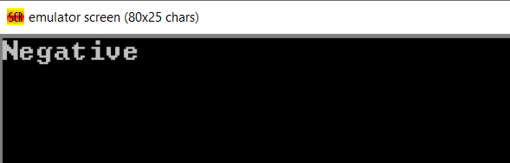

Conclusion: The assembly code examples illustrate fundamental concepts like setting up data and code segments, handling input/output, conditional logic, and array manipulation. These basics provide a strong foundation for understanding low-level programming and efficient hardware control.

